Project Overview:
The following analysis was performed in order to help understand how different Kickstarter Campaigns fared in relation to their launch dates and fundraising goals.

Analysis and Challenges:

This analysis was completed by comparing the total number of successful and failed pledges against their start date relative to the quarter.
In order to do this, we first must analyze the outcomes of successful campaigns against the goals set to determine what qualifies as a successful campaign. See chart below:
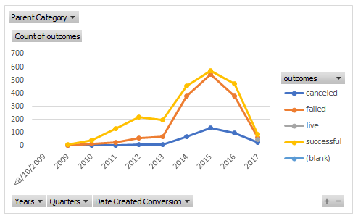
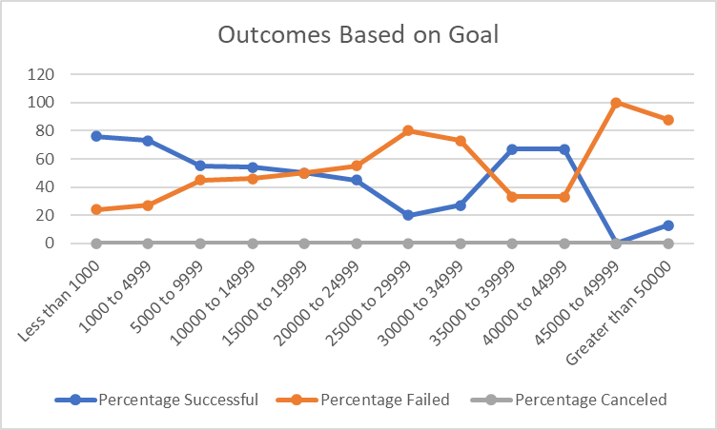
Above, we can see the relationship between a successful goal (based on a range) and the percentage of completing that goal.

Finally, we can identify based on our table “Outcomes Based on Launch”, that though the data is heavily skewed, it is also possible to say that most of the successful theatre campaigns are run in the 3rd quarter of the year and the least successful theatre campaigns are launched within the first quarter. Also, based on the goal amount, we can say that if the goal is within a range of less than $1000, the campaign is nearly 80% more likely to succeed.

